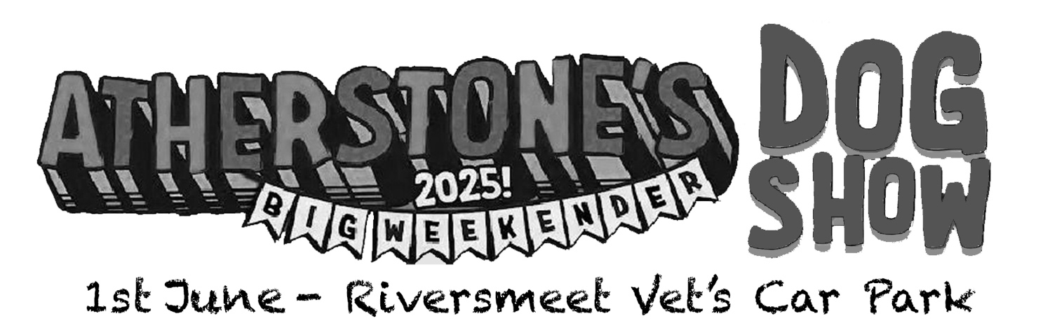

Registration Form
Pet’s Name: ___________________________________________________________
Pet’s Breed : ____________________________________ Pet’s Age : __________
Owner’s Name: _________________________________________________________
Contact Number: ________________________________________________________

Entrance fee of £5 per category inclusive of a complementary goodie bag for first 100 registrations
Prizes for 1st and 2nd placed entries, proceeds donated to

Categories to Enter
☐ Best dressed dog & owner (10am)
☐ Best golden oldie (10:15am)
Pet First Aid Demo with Animals at Home (10:30am)
☐ Best puppy (10:45am)
☐ Best owner / dog look-a-like (11am)
☐ Happiest / grumpiest dog (11:15am)
Coat maintenance talk with Wags K9 (11:30am)
☐ Scruffiest dog (11:45am)
☐ Best ears (12pm)
Pet First Aid Demo with Animals at Home (12:15pm)
☐ Best rescue dog (12:30pm)
☐ Best treat catcher (1pm)
** Please use the rear of this form to supply some supporting details about your pet **





